Dictionary in Python
Last updated on September 23, 2020

Dictionary is another built-in data type which allows us to store a collection of key-value pairs.
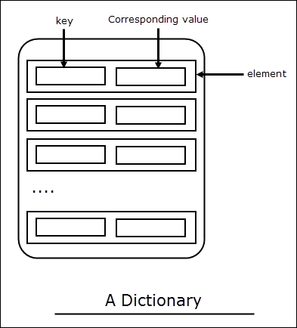
As you can see in the image. Each element in a dictionary has two parts: a key and a value.
Think of Dictionary like a list, unlike a list, however, elements stored in the dictionary are stored in no particular order and we use a key to access a specific value. Most of the time key is a string, but it can be any immutable type such as int, float, tuple, string etc. Each key maps to a value, so we can't have duplicate keys. Dictionaries are mutable objects which means we can add, remove, or update the elements after it is created.

